Zoonotic Diseases of Sheep and Goats
Felton DeRouen II
Sustainable Plant and Animal Production Systems
Agricultural Research and Extension Center
Southern University and A&M College
Telephone (225) 771-2234
Email: felton_derouen@suagcenter.com
“Linking Citizens of Louisiana with Opportunities for Success”

Zoonotic Diseases from Sheep/Goats

Zoonosis:

A zoonosis is an infectious disease that can be transmitted between a non-human animal and a human. These zoonotic agents can be viral, bacterial, or parasitic. They can be transmitted via direct contact, food, the environment, or water.

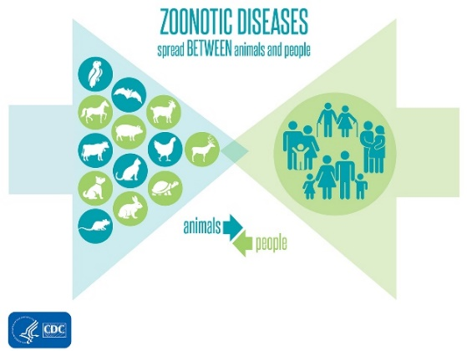

Campylobacteriosis

A major cause of enteritis in humans, Campylobacter spp. (e.g., C. jejuni and C. coli) often infects people by the consumption of contaminated or undercooked meat and unpasteurized milk or dairy products (oral). People can also be infected by untreated water or contact with infected animals or feces. People infected with campylobacteriosis can have diarrhea, fever, nausea, vomiting, abdominal pain, headache, and muscle pain. People with compromised immune systems are at higher risk for severe or recurrent infections.

Salmonellosis

People most commonly get salmonellosis from eating improperly cooked food, such as meat, eggs, or unpasteurized milk/dairy products (oral). People can also get salmonellosis by direct contact with feces/diarrhea from infected animals. People with salmonellosis may have diarrhea, fever, and abdominal cramping.

Listeriosis

Listeria monocytogenes causes listeriosis, a bacterial disease in ruminants and humans. Most infections in people occur by eating raw meat or unpasteurized dairy products (oral), but there are additional ways to be infected. Animals can shed L. monocytogenes in the feces, milk, and uterine discharges. Pregnant women or immunocompromised people should take special care to avoid unpasteurized dairy products. Unlike other bacteria, L. monocytogenes can grow in cold temperatures, including in the refrigerator. A skin infection form of the disease can occur in people who handle sick animals.

Escherichia coli (E. coli)

Although most Escherichia coli are harmless bacteria and part of the normal intestinal flora, some serotypes such as E. coli O157:H7 can cause intestinal disease (food poisoning) in humans, resulting in bloody diarrhea, kidney failure, and death. People can become infected by ingestion following contact with feces of infected animals (and humans) in contaminated food, and water.

Funding Source: The USDA 1890 Evans-Allen Program project accession no. 1021121 from the USDA National Institute of Food and Agriculture.

For more information contact:
Dr. Renita W. Marshall, DVM, MS
Telephone: (225) 771-0252
Email: renita_marshall@suagcenter.com
or Dr. Dana Pollard, PhD, MS
Telephone: (225) 771-3505
Email: dana_pollard@suagcenter.com

Southern University Agricultural Research and Extension Center, an entity of the Southern University System, Orlando F. McMeans, Chancellor-Dean; Dennis Shields, System President-Chancellor; Edwin Shorty, Esq., Chair, Board of Supervisors. It is issued in furtherance of the Cooperative Extension Work Act of December 1971, and the Agricultural Research Program, in cooperation with the U.S. Department of Agriculture. All educational programs conducted by the Southern University Agricultural Research and Extension Center are provided to all persons regardless of race, national origin, or disability. © 2022 SU Ag Center.

